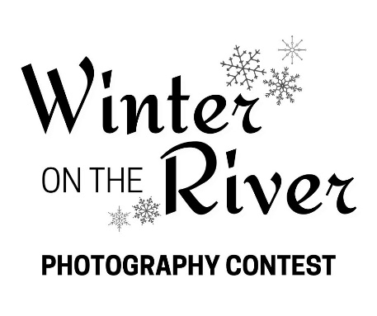

BROUGHT TO YOU BY MEETING OF THE RIVERS FOUNDATION

Please review the information provided below to ensure you have a full understanding of the operations of this photography competition. Any additional questions can be addressed by contacting Meeting of the Rivers Foundation. Proper communication outlets can be found at the bottom of this document.
SUBMISSION INSTRUCTIONS | DEADLINE_________________________________
Deliver your entries in person (Daily 9:00 a.m. – 5:00 p.m.) or plan ahead and send by mail to be received by the deadline.
*** Entries must be RECEIVED by ***
Monday, December 18, 2023, 5:00 p.m.
Submissions will be accepted November 1, 2023 – December 18, 2023, via online registration.
Submissions must be received both digitally and physically. Digital entries must be in JPEG form and emailed to meetingoftherivers@gmail.com. Each photo must be saved with the artists name and title of the photo. Physical entries must be delivered or mailed to the National Great Rivers Museum.
Entry Fee The entry fee is a one-time, non-refundable fee of $10.00 per photo. Each artist may submit up to 3 photos.
Framing
All photographs must be framed in a professional manner with braided wire attached for hanging. Do NOT use saw-tooth hangers, string, or single strand aluminum wire. Use braided wire specifically made for your picture/frame weight.
Delivery of Physical Artwork
Hand deliver or mail. Artwork must arrive no later than Monday, December 18, 2023, at the National Great Rivers Museum: Open Daily 9:00 a.m. – 5:00 p.m.
Exhibition Schedule
January 6, 2024 – March 9, 2024. Artwork cannot be removed before the exhibit closes.
Pick-Up Physical artwork must be picked up during the week of March 11 – 17, 2024. 9:00 a.m. – 5:00 p.m. Any entries not picked up within the specified time frame will be forfeited to the National Great Rivers Museum and become a donation to the Meeting of the Rivers Foundation.
CONTEST REGULATIONS_______________________________________________
Eligibility
This is a competition open to all professional and amateur artists of any age who live or have traveled along the Mississippi River watershed or one of its major tributaries.
All entries must have the Mississippi River as the overarching subject and display a winter theme.
Categories include landscape, wildlife, industry, and recreation.
For the purposes of this competition the definitions of each category are as follows.
Landscape – images of the natural environment (land or water) encompassing the river.
Wildlife – images of the native animal species in their natural settings, like in a forest or underwater.
Industry – images of the various production or transportation enterprises that utilize the river.
Recreation – images of either people, or the associated objects, actively enjoying the river.
Accepted Media & Specifications
Photography: photographic film and digital photographs.
Exhibited photos must be no smaller than 8×10 and no larger than 12×18 in size, printed in a professional manner, and have quality resolution that matches the image submitted digitally.
All work must be original work of entrant. No third party may own or control any materials the photo contains, and the photo must not infringe upon trademark, copyright, moral rights, intellectual rights, or rights of privacy of any entity or person.
All work must be in its original state and cannot be altered in any way, including but not limited to removing, adding, reversing, or distorting subjects within the frame.
Meeting of the Rivers Foundation reserves the right to reject any entries that do not meet the prospectus requirements.
Entry Quantity & Fee
The entry fee is a onetime, non-refundable fee of $10.00 per photo. Each artist may submit up to 3 photos.
Judging
Meeting of the Rivers Foundation invites a panel of leading community members of the region to serve as judges for the competition. After viewing each physical entry with photographer name withheld, the judges select the top award winners from the exhibition group. Visitors to the National Great Rivers Museum are invited to select a top award winner, “Public Choice” through in-person voting during the exhibition as well. All award winners will be announced on Saturday, March 2, 2024, 9:30 a.m.
Prizes
Best of Show: $100.00 cash prize. Runner-Up: $50.00 cash prize. Best of Category: Certificate. Public Choice: Certificate. Participation Certificates for all entries.
Contest Contingency
This photography competition is contingent on the number of registrations received. There must be a minimum of 20 paid photo entries for the cash prizes to become available.

CONTACT INFORMATION______________________________________________
Digital Entry
Artists should provide their entries in JPEG form with their name and title of the photo(s) to the following email address.
meetingoftherivers@gmail.com
Mail In Entry
Artists who wish to mail their entries to the National Great Rivers Museum should use the following mailing address.
ATTN: Elise Ratcliff
Meeting of the Rivers Foundation
2 Lock and Dam Way
East Alton, Illinois 62024
In Person Entry
Artists who wish to deliver their entries by hand should use the following street address.
National Great Rivers Museum
2 Lock and Dam Way
East Alton, Illinois 62024
Open Daily 9:00 a.m. – 5:00 p.m.

We appreciate your participation in the 2023 Winter on the River Photography Contest and look forward to sharing your unique works with the public.
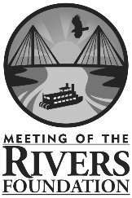
Contest Coordinator
Elise Ratcliff
618-462-6979
elise.ratcliff@usace.army.mil

